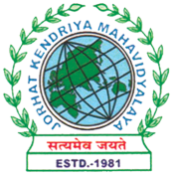
Department of History
JORHAT KENDRIYA MAHAVIDYALAYA
Estd.1981
KENDUGURI, JORHAT-785 010, ASSAM
“Re-accredited by NAAC Grade-A
E-mail: historydocu4@gmail.com
College Website: jorhatkendriyamahavidyalaya.in

Ref: ………………… Date: 23.08.2025

Observation of the Tithi of Mahapurush Srimanta Sankardeva
Organized by the Heritage Club, Department of History

The Department of History, Jorhat Kendriya Mahavidyalaya, through its Heritage Club, organized a programme on 23rd August 2025 to observe the Tithi of Mahapurush Srimanta Sankardeva, the great saint, social reformer, and cultural icon of Assam. The programme commenced with a Borgeet. Two seminar papers were presented by students, focusing on different aspects of Sankardeva’s life and works.The resource person of the event was Dr. Bishnu Ram Nath, Associate Professor, Department of Assamese, who delivered an insightful lecture highlighting the contributions of Srimanta Sankardeva in the spheres of religion, literature, culture, and social harmony.

